Okta Application Instructions
First time applicants often get an Error message when trying to access the accreditation application, please follow the instructions below to access the portal. Should you need further assistance, please contact the program at 406-444-5300 or deqacponline@mt.gov.
On the dashboard, select add apps
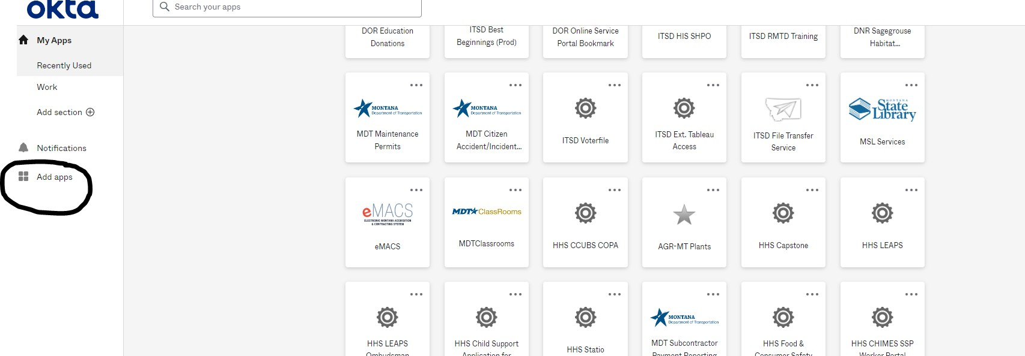
Search for the application or scroll through the list until you find the application. Click the add button. Note that you will need the ITSD Asbestos Accreditation app, not the ITSD Asbestos Accreditation Admin app. This app is for department use only.

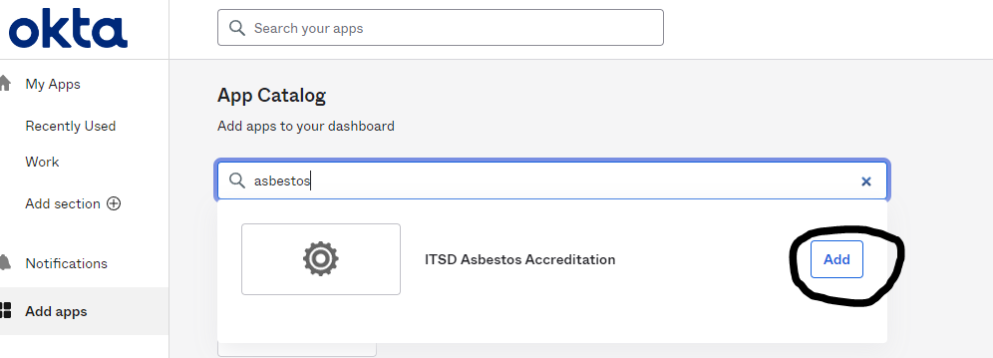
Click on my apps and the application will be on your dashboard. You may use the widget to navigate to the website or reach the site by your normal message.

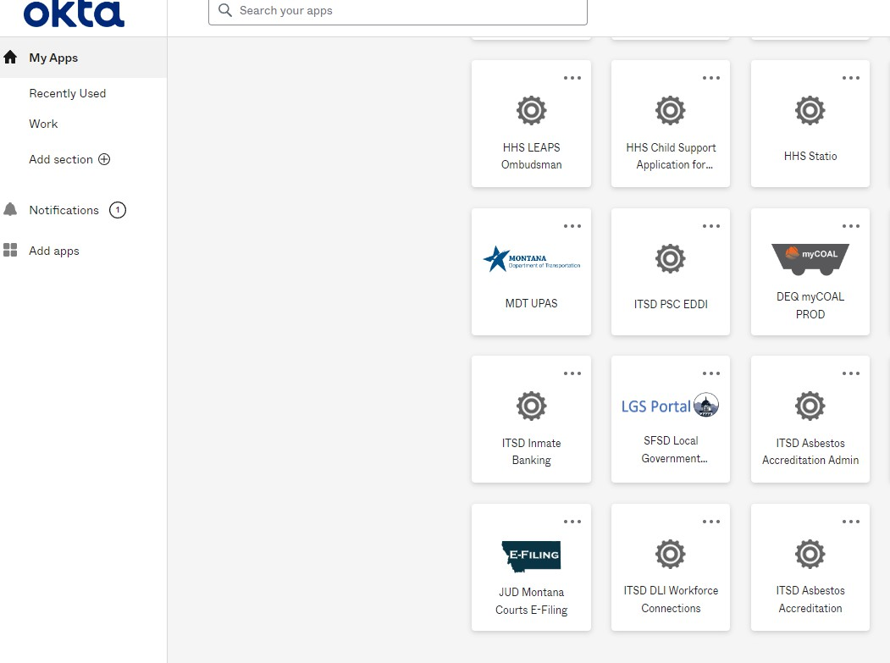

Access should be granted. If not, please contact the program for further assistance. 406-444-5300 or deqacponline@mt.gov.

